

Sixty-Four Pixels

Lo-Fi Games Console

Build Guide

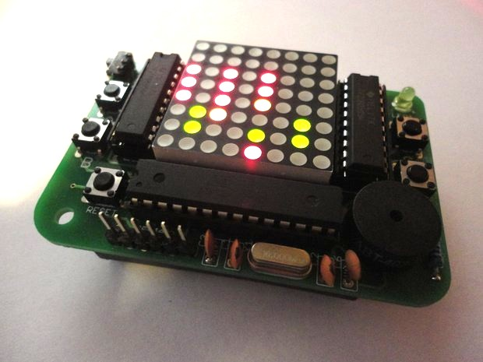

# What's in The Kit?

## Printed Circuit Board

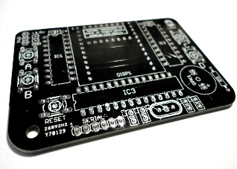

*The board is made of a fibreglass material with copper tracks on either side and holes drilled through. The holes are plated with metal and we can solder our components into them. There are some very small plated holes called “vias” which join up the copper tracks on either side of the board.*

*The board is painted with a layer of black ”solder mask” which protects the copper tracks, and on top of that is the white print (“silk screen”) which adds labels. We use “component designators” like R2, IC1 etc. to label which component goes where.*

*These boards are made in a factory, but you can design your own board layouts and get order them in small batches quite cheaply from factories in China!*

## Bi-Colour 8x8 LED Matrix

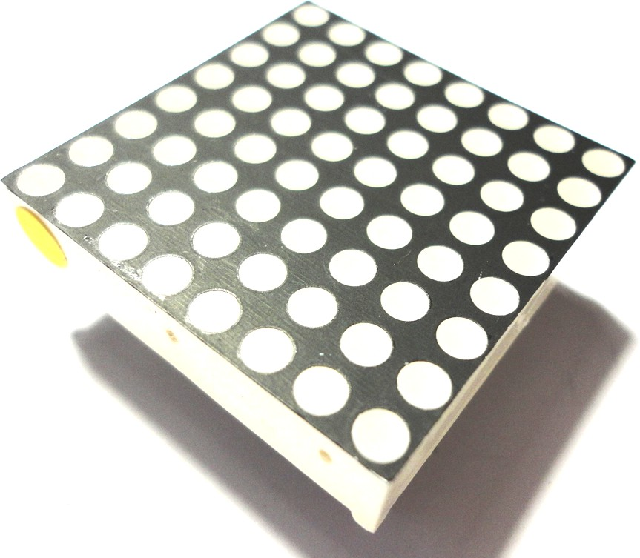*This is a little grid of LED (Light-emitting diode) lights that we'll use as a display for our game. Behind every single one of the 64 pixels are two tiny LEDs; one red and one green*

*- that’s a total of 128 LEDs! As well as red and green we can get yellow by mixing these two colours*

*The LEDs are wired in a grid of 8 columns and 16 rows (8 for red and 8 for green). This means that there are only 24 pins needed to control all the LEDs. To make a given LED come on we need to apply a voltage between the correct row (-) and column (+) pin*

*The long lead of an LED is the (+) connection and the short lead is the (-) connection. These are often called the “anode” and “cathode” respectively.*

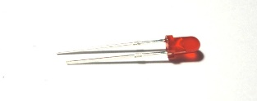

**3MM LED - LED1**

*This is a single LED light which flashes as an “I'm Alive” indicator on the game board. Inside the plastic dome of the LED is a tiny silicon chip which actually emits the light.*

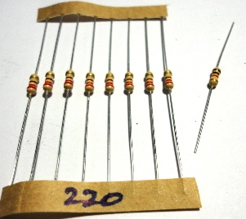

## 8 x 220 Ohm Resistors - R1...R8 1 x 1K Ohm Resistor - R9

*Like a narrowing in a water pipe, resistors restrict the flow of an electric current. Compared to LEDs they might seem a bit dull, but they can be applied for many interesting purposes and are probably the most used components in electronics! In our games console we simply use them to restrict the current flowing into our LEDs. Without the resistors, the LEDs would quickly burn out in a blaze of glory...*

*Resistors come in many different values, which are indicated by colour-coded stripes on the resistor body. We'll use resistances of 220 ohm (Red-Red-Brown code) and 1k ohm (1000 ohm) with Brown-Black-Red code.*

*The actual colour of the resistor body itself (tan, pale blue etc.) is not important for determining the resistance value.*

## 4 x 100nF Ceramic Capacitors (104 Code) - C3, C4, C5, C6

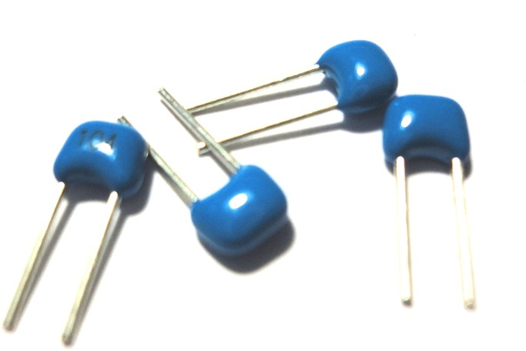*Capacitors store a small amount of electric charge, like a tiny rechargeable battery. We use them to “smooth” the voltage at various points in our circuit.*

*Capacitors can also be used to allow a changing voltage signal to pass through them, while blocking any continuous current flow. We use one on our speaker.*

*Capacitors are marked with a numeric code representing the capacitance in units called picofarads.*

*The 104 code of the 100nF capacitor does not mean “a hundred and four” but instead means “10 followed by 4 zeroes”, or 100,000 picofarads.*

*Since there are 1000 picofarads (pF) in a nano-farad (nF), we can also call this a 100nF capacitor. Or even a 0.1uF (microfarad) capacitor!*

## 2 x 33pF Ceramic Capacitors (33 Code) - C1, C2

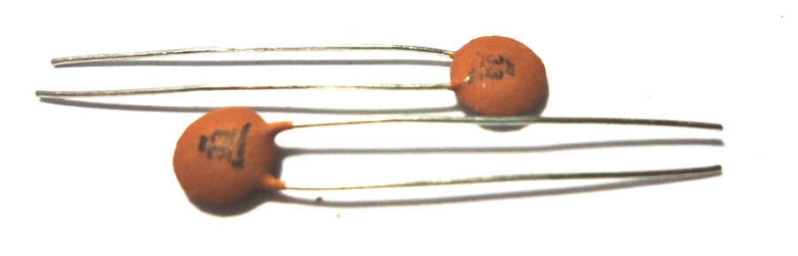*At only 33 picofarads, these capacitors have a much lower capacitance than the 100nF ones (over 3000 times less)*

*They are used with the crystal (see next) to ensure it runs correctly*

## 16 MHz Crystal - X1

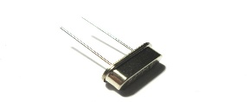

*The heart of the games console is a microprocessor, just like in a PC.*

*Like the PC, our processor needs an “clock” to make it run... While a PC might have a clock speed of a few Gigahertz. our games console runs at 16MHz (That is still sixteen million ticks every second!). This crystal is what keeps the clock ticking.*

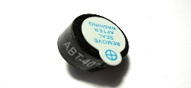

**Piezo Buzzer - SPK1**

*This is how we'll make our bone shaking sound effects! This device contains a little “piezo disc” which vibrates when electricity is applied to it. We can use this to make beeps and bloops for our games!*

*These types of speakers are often used in alarm clocks and buzzers on kitchen equipment etc.*

## 5 x 6mm Momentary Tactile Switch - A, B, C, D, RESET

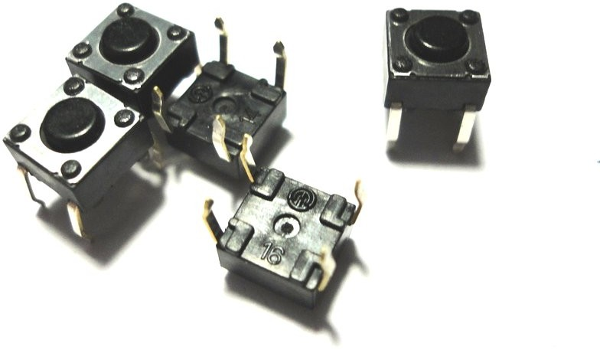*These small clicky switches are what we'll use to control our console.*

## Sub-miniature Slide Switch - PWR

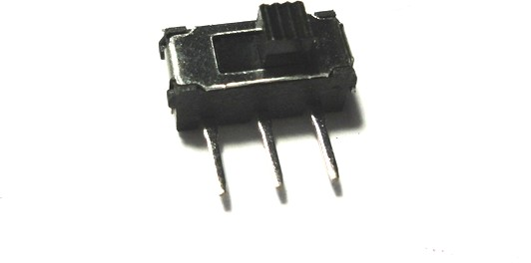*The all-important power switch that allows us to turn the power off and save the battery when the game is not in use.*

## ATMEGA328P Microcontroller - IC3

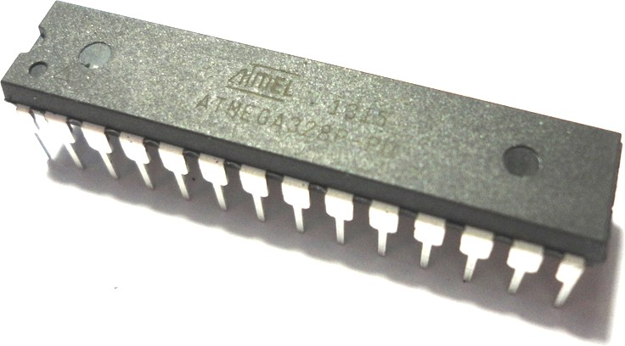*Believe it or not, this is a complete computer on a chip! just like a PC it has a processor, memory and program storage (a kind of built-in flash drive). All it lacks is a screen and a keyboard (which is where the other parts of the circuit come in...)*

*The microcontroller comes pre-programmed with the games program so it should be ready to run once you have built the circuit.*

## 2 x Open Collector Shift Register TPIC6B595N - IC1, IC2

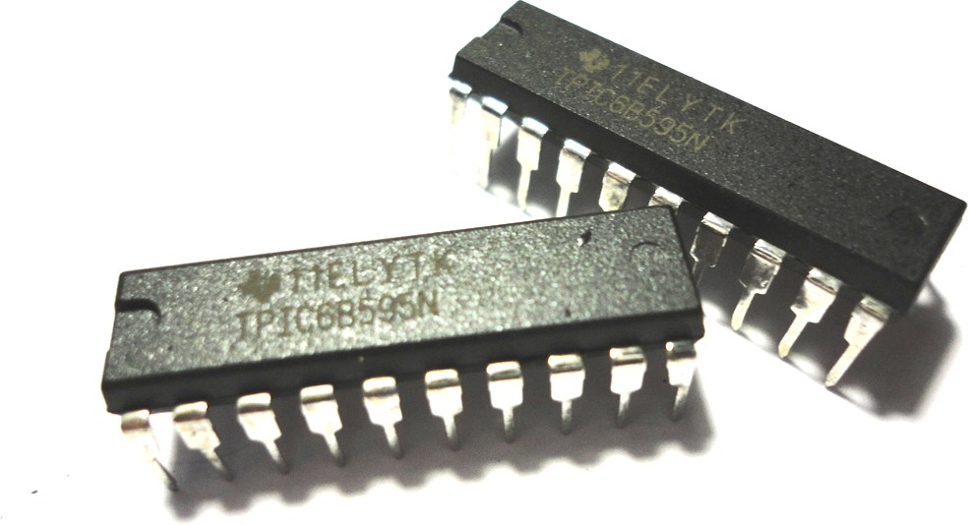*We use these components to help the microcontroller talk to the LED matrix. Each one is like a set of eight electronic switches that we can turn on or off in any combination by sending a special series of ON and OFF pulses to it.*

*These two components together allow us to control all 16 (-) pins of the LED matrix with just 3 connections to the microcontroller.*

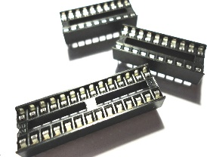

1. **x 28pin IC Socket - for IC3**
2. **x 20pin IC Socket - for IC1, IC2**

*It is always a good idea to mount integrated circuits (“ICs” like the microcontroller and shift registers) in sockets rather than soldering them directly to the board.*

*Using sockets prevents the sensitive IC's getting heat damaged during soldering and allows them to be replaced easily if needed.*

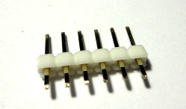

**6 Way Pin Header - SERIAL**

*This allows us to attach a USB programmer to the console so that we can load new programs onto it*

## 3XAAA Battery Box

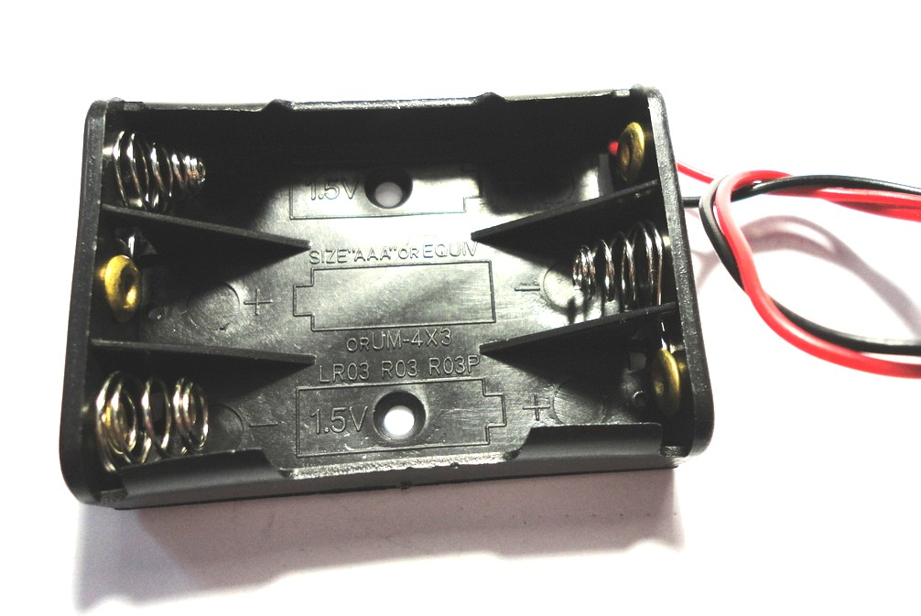*We'll run our console on the 4.5 volts we get from three AAA batteries (1.5V each)*

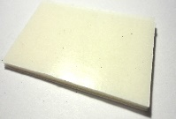

**Sticky pads**

*For attaching the battery holder to the back of the board... 'nuff said.*

# How to Solder

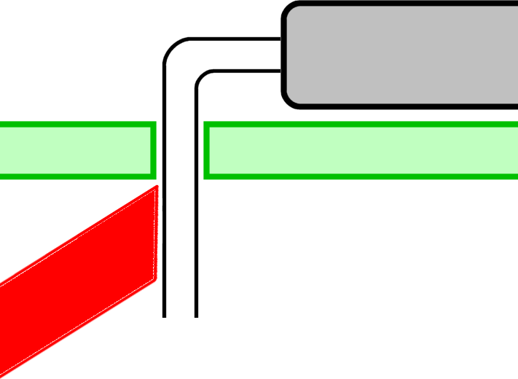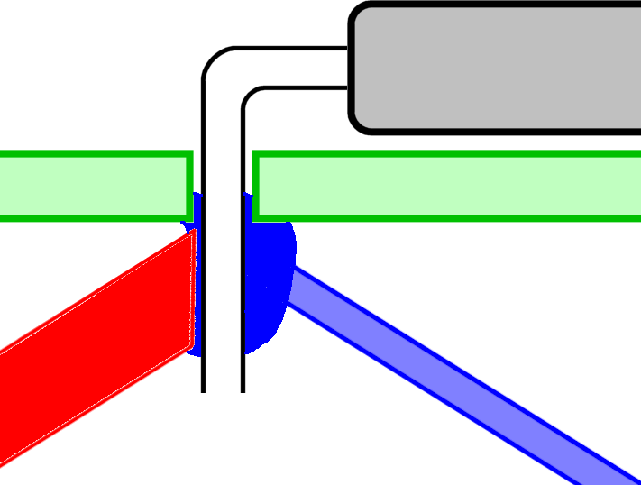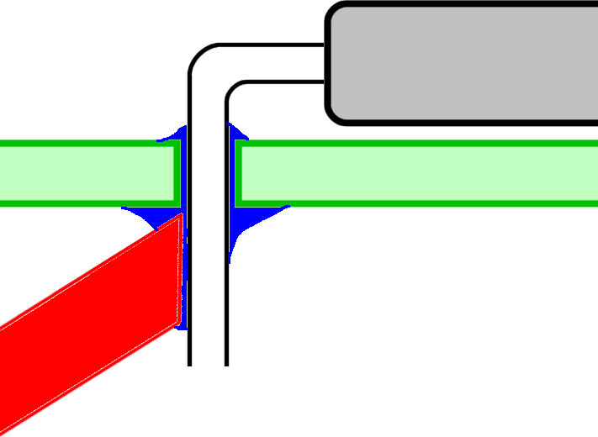

**Step 1** - Press the tip of the soldering iron as close as possible to the joint between the leg of the component and the pad on the printed circuit board. Heat for 2-3 seconds.

**Step 2** - While still heating the joint with the iron, *feed in the solder wire* at the point where the iron tip and the component lead touch. Use a little less than 1cm length of solder wire for each joint. This process should take 2-3 seconds.

**Step 3** - Remove the solder wire and keep heating the joint for another 2-3 seconds. This allows the solder to spread and be drawn through the hole, making a good connection.

# A Good Solder Joint

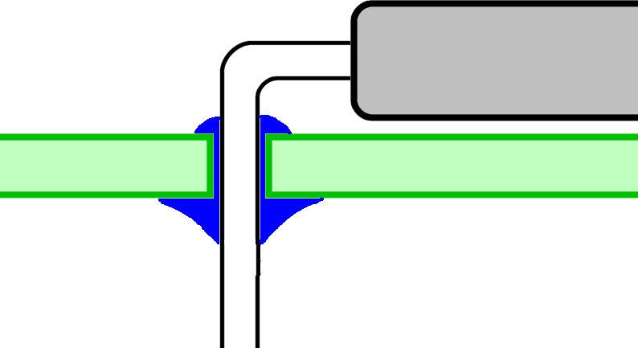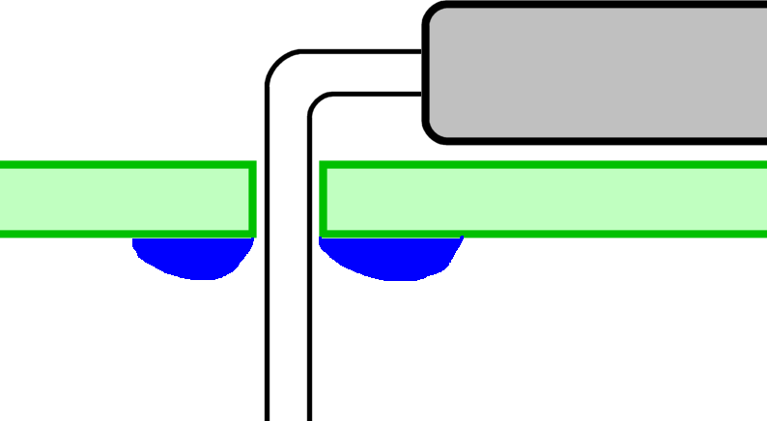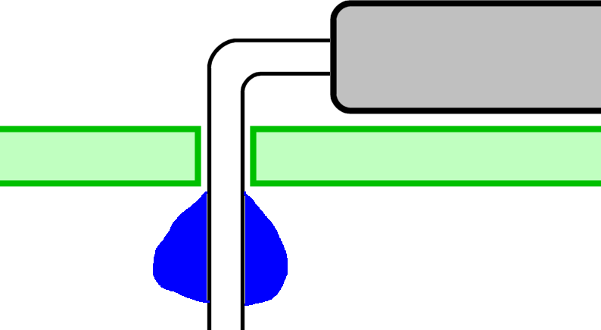

**GOOD:** This is what we're aiming for. A good solder joint with solder being drawn right through the hole. The solder joint should be bright and silvery.

**BAD:** The iron was only heating the pad, not the component lead, so the solder has not adhered to the lead but has formed a ring around it on the pad. The two are not properly connected - try again!

**BAD:** The solder is only on the lead, but has not joined it to the pad. This is a very common mistake. Try again!

# Trimming Excess Leads

After the joint has cooled, trim excess leads with side cutters. Try to push down on the joint with the cutters rather than tug at it. What we are aiming for is shown below.

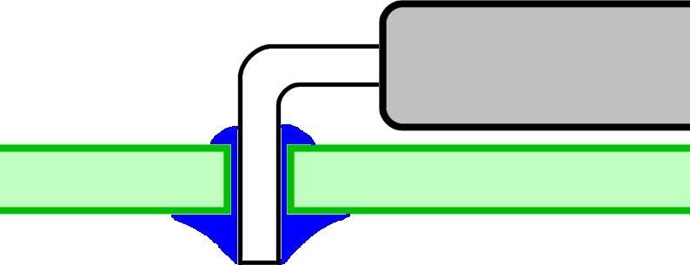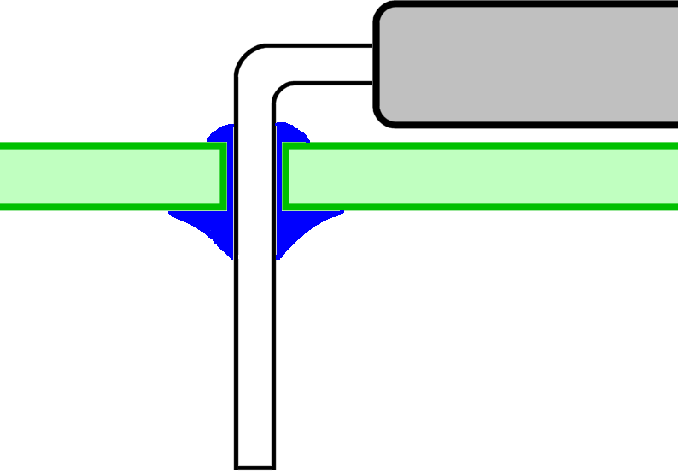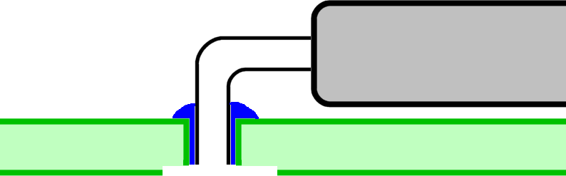

**GOOD:** Nice neat cut just above the solder joint. No excess component lead and no damage to the joint

**NOT SO GOOD:** Excess leads could touch together causing shorts or other problems.

**BAD:** Too close to the board**.** The bottom part of the solder joint could get damaged or even pulled away from the track.

# Build Instructions

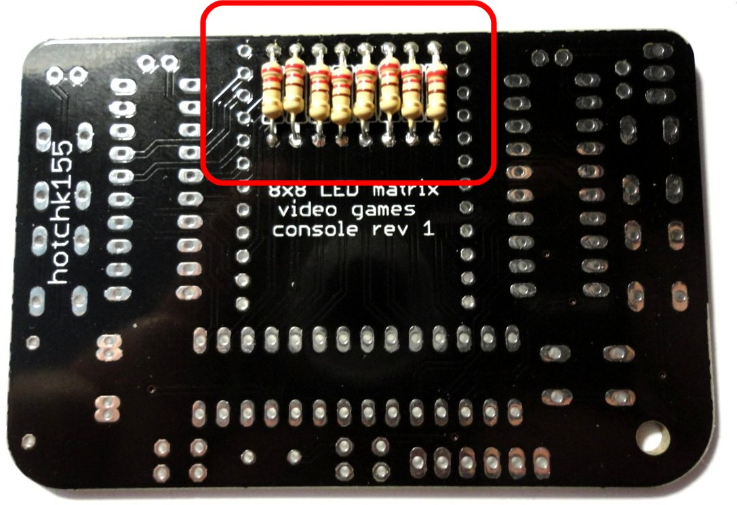Let’s start off by turning the board over and soldering the **eight 220 Ohm resistors** to the back. These have a colour code of RED-RED- BROWN. There is one other coloured stripe (often gold) which we can ignore.

Resistors do not have a special polarity and can be soldered either way around in their positions, which are marked R1 through R8.

## Please make sure you are putting them on the back of the board not the front!

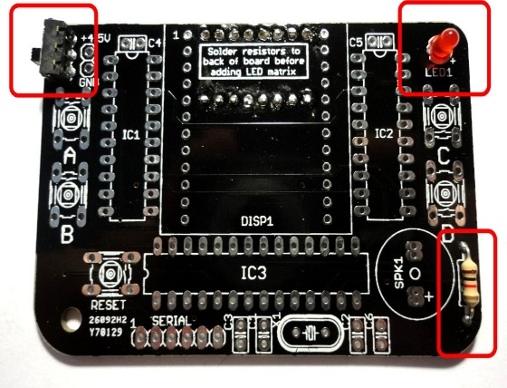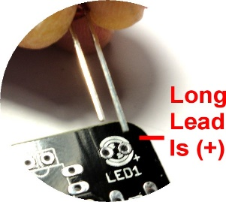

Now let’s turn the board back over and add the **1K resistor**. This one has a colour code of BROWN-BLACK-RED and fits into the position marked R9

Let’s also add the **LED** and the small **Slide Switch**. When adding the LED, put the long lead through the hole marked (+)

Next add the **Crystal X1** and the **33pF capacitors; C1 and C2**

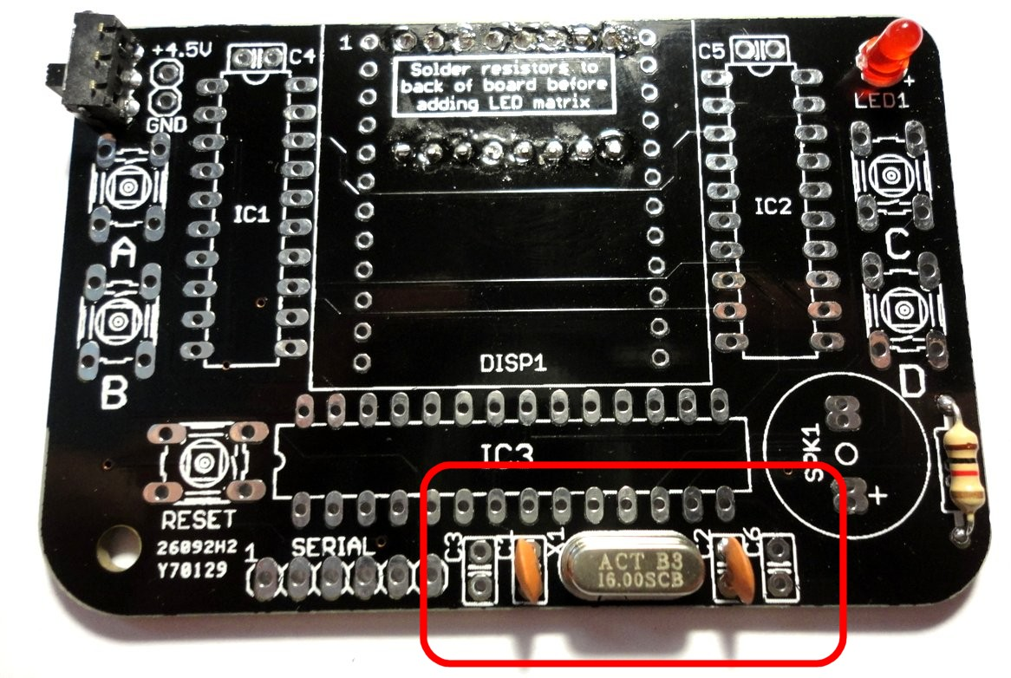which fit either side of it.

Your kit contains two types of capacitors, so be sure to pick the correct one!

## The 33pF capacitors are marked with the number code “33”

and your kit contains two of them.

These components do not have a specific polarity so you can fit them either way around in their position

Now let’s add the **four 100nF capacitors; C3, C4, C5 and C6.**

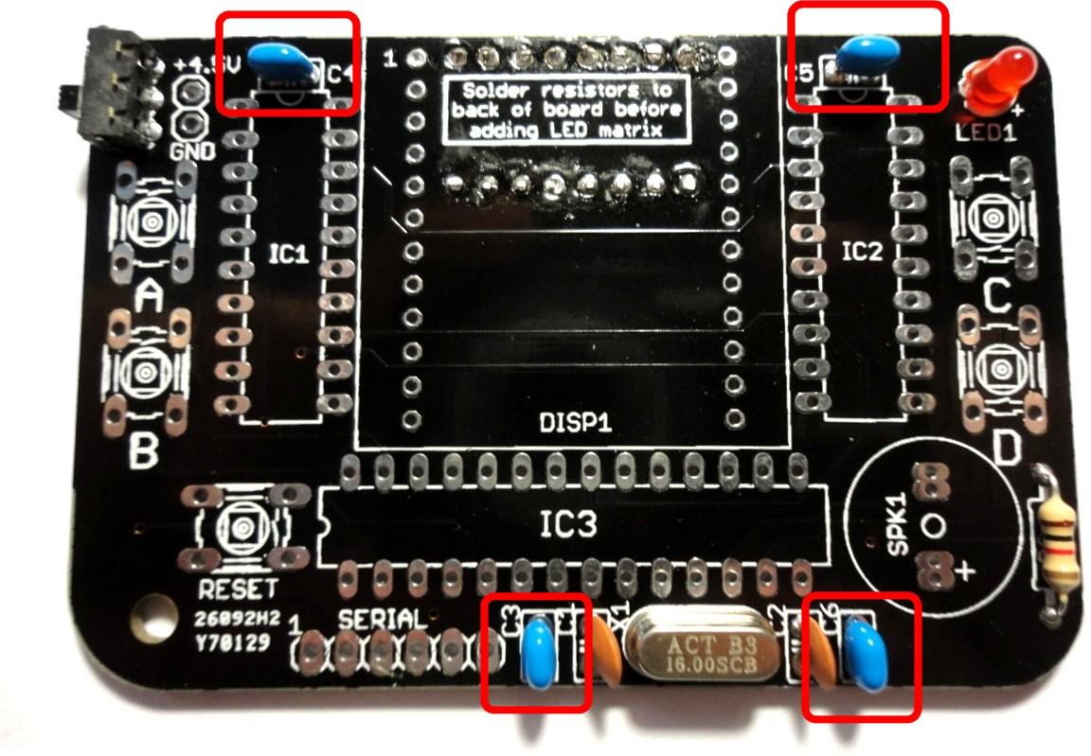These are marked with a number code “104”

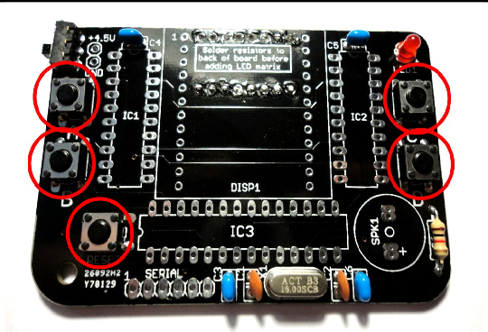

Next up are the **five push button switches A, B, C, D and RESET**

When you solder these, you need to make sure they are fitted nicely and snugly against the board, as you'll be pressing these a lot when you're playing games and don't want them breaking off!

A good tip is to start by soldering just two opposite corners on each switch, so you can check the position and adjust as needed before finishing up by soldering the other two pins.

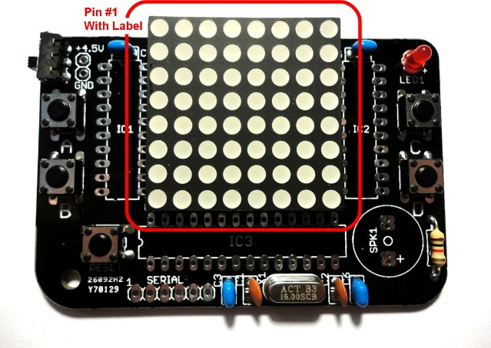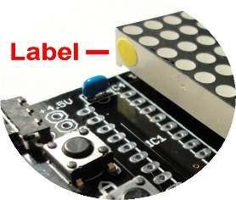

Next, we will add the **8x8 LED Matrix**. This **does** have a specific polarity.

**It is very important that you attach this the correct way around or it will not work, and it will be very difficult to remove!**

One corner of the matrix is marked with a small label. This corner should be oriented at the top left corner of the matrix when it is placed on the board. Please seek assistance if the label is missing!

It can be fiddly to get all the legs of the matrix through all the holes. Make sure all the legs are straight before you begin and be patient - Do not try to force it or you may bend or break the legs off!

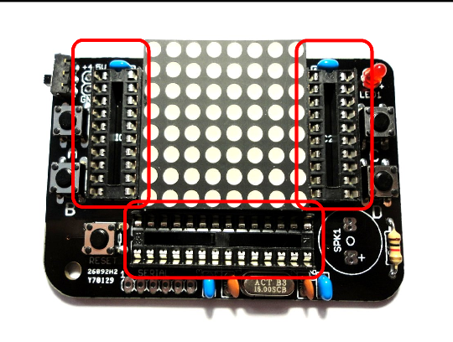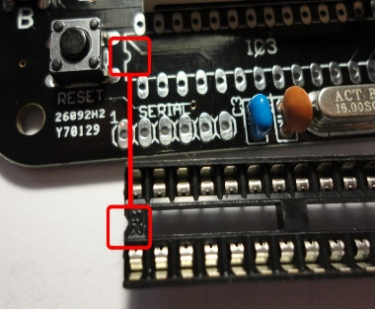

Now we will add the three integrated circuit (IC) sockets. There are two types in your kit; one is a 28-pin socket with 14 legs on each side. The other two are 20-pin sockets with 10 pins on each side.

The 20 pin sockets fit in positions IC1 and IC2, and the 28-pin socket fits into position IC3.

The sockets have a small “notch” at one end which should be aligned with the notch marked on the circuit board, as shown below:

Next up are the **speaker SPK1** and the **SERIAL pin header**.

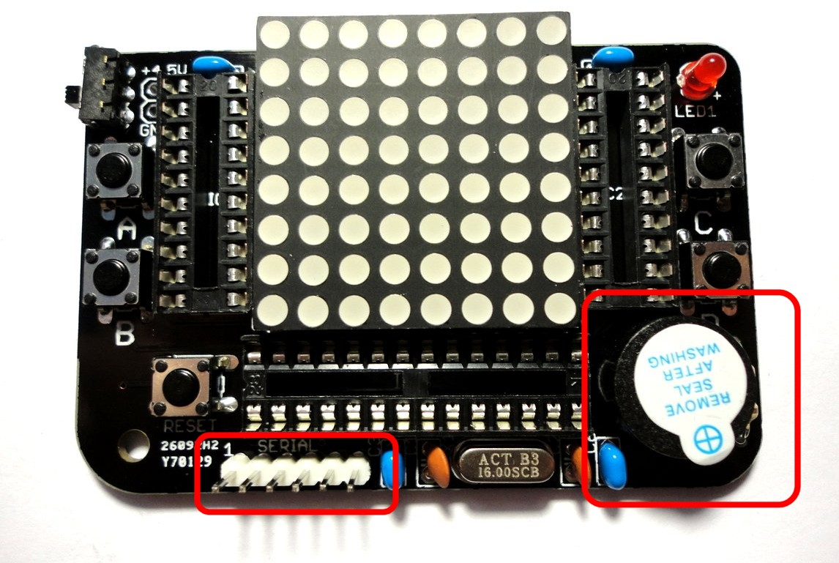The speaker needs to be attached the correct way around, with the (+) terminal towards the lower edge of the board

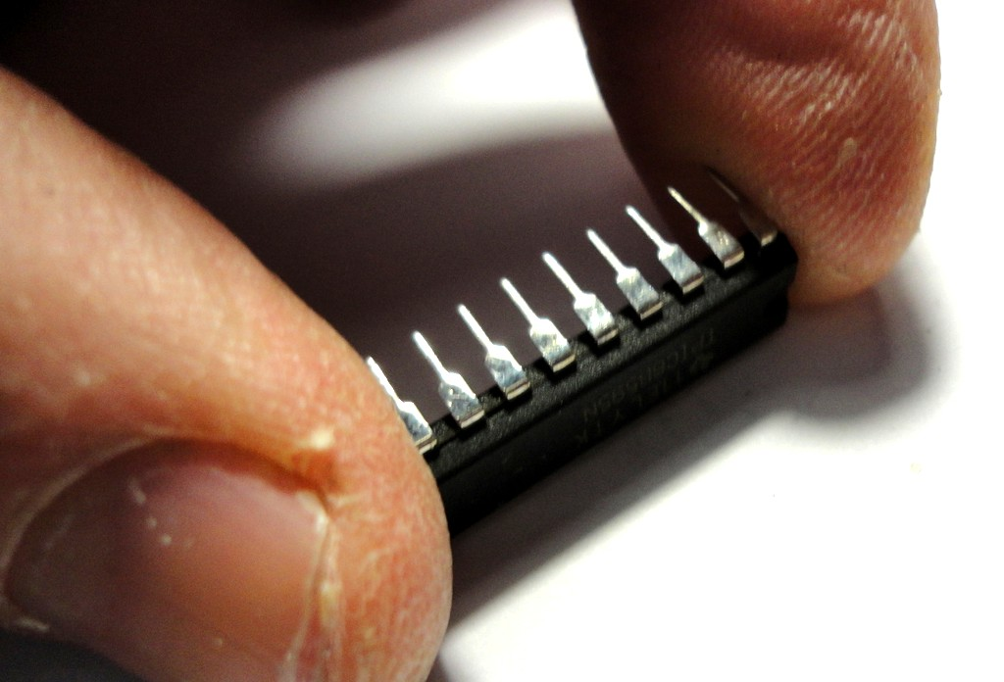

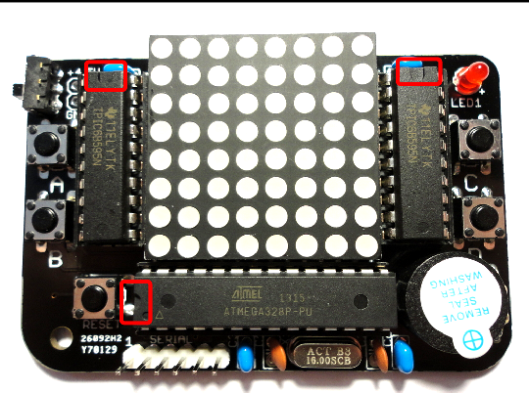

Now it’s time to put the “chips” (integrated circuits, or ICs) in their sockets.

**IC's can be damaged by static electricity, so before this step, touch a grounded metal object to make sure you discharge any static that has built up.**

Match up the components with the sockets having the matching number of pins, and make sure that the “notch” at the end of the ICs are in the correct places. The picture to the right shows the correct location of the notches.

The rows of legs on ICs face slightly outwards and

it can sometimes be easier to insert the IC's if you press the legs gently against a flat surface to get them at a ninety-degree angle to the IC body before trying to put them in the socket.

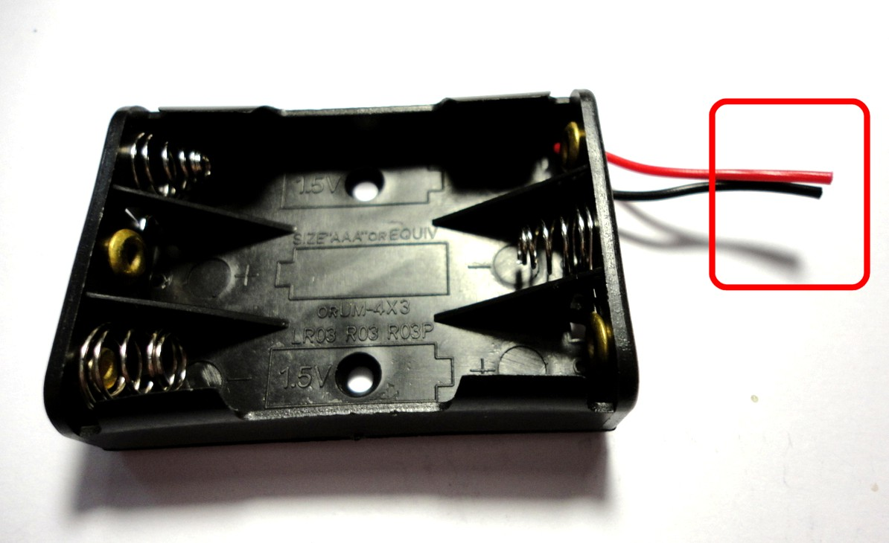Ensure the IC's are fully in the sockets but be gentle and do not force them. Ask for assistance if needed!

And so on to the battery box... start by trimming the leads to about 3cm as shown.

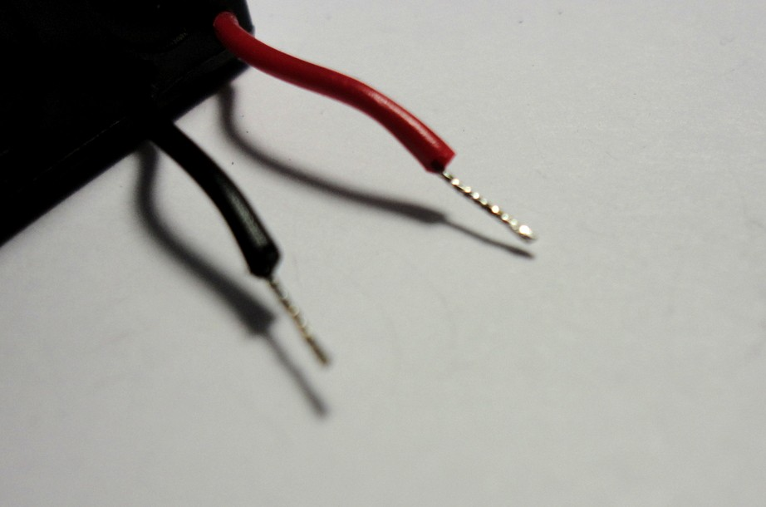Strip a small amount of insulation from the ends of the wire and twist the strands together neatly.

“Tin” the wires with a small amount of solder. This should bind the strands together and give the end of the wire a clean silver coating as shown.

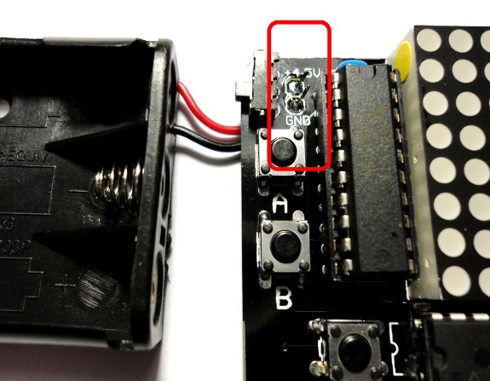

Solder the wires to the board, inserting them from the back and soldering them on the front.

The red wire goes through the hole marked +4.5V and the black wire goes through the hole marked GND.

Once soldered, trim off the excess bare wire on the top of the board to make sure the wires cannot touch each other.

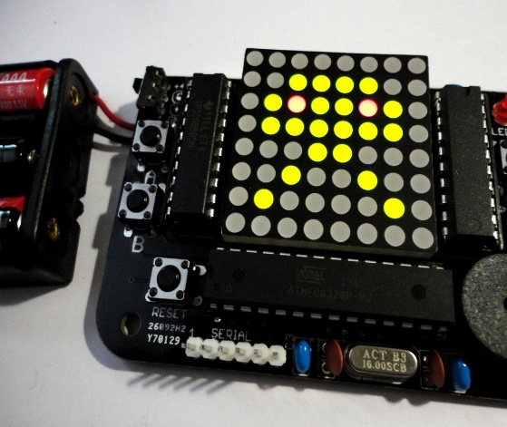

Time for the moment of truth!

Insert the batteries into the holder and tun on the power switch. You should be greeted with the game menu as shown.

If nothing happens, ask for assistance - we will check what is wrong and help you to fix it before moving to the next step.

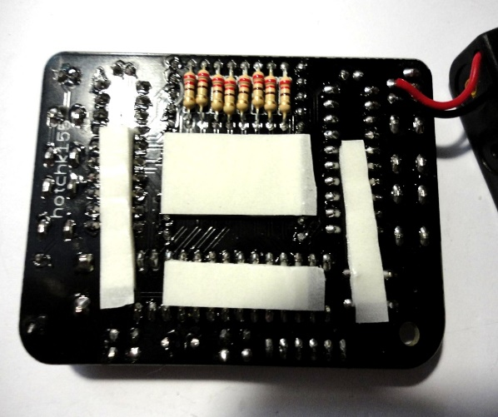

Turn the power off and let’s get ready to attach the battery box to the back of the board using the supplied stick pads.

I suggest cutting the pads to size and attaching to the back of the board as shown.

Make sure all component leads are trimmed nice and short before applying the pads.

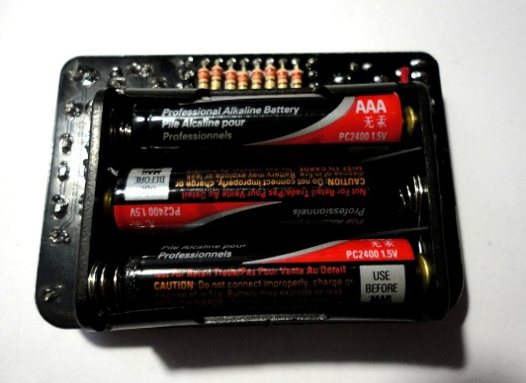

Now peel and stick! make sure the battery box is attached firmly.

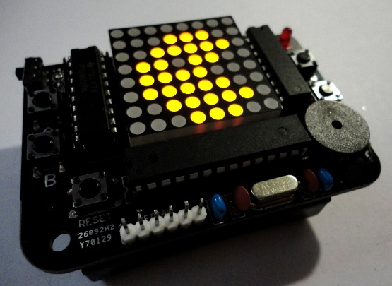

You made your own games console! Well Done!

**What Next...?**

Hopefully you enjoyed building this kit! If you'd like to learn more about this project, including how to write your own games and load them on to the board, please check out the information online at **https://github.com/hotchk155/AVRGame/wiki**

If you are interested in making your own projects like this, a good way to get started is with an 'Arduino' development board (take a look at **http://www.arduino.cc**). There is a great global community using this hardware and loads of projects to try. It is a great way to get into electronics and programming.

**Playing the Games**

Navigate the main menu by pressing B or D to select a game icon. Press C to start a game Press and hold buttons A+C to return to the menu while a game is in play

If the game is over, press RESET then hold A+C to return to menu

## INVADERS GAME

* Press B and D to move LEFT/RIGHT
* Press C to FIRE
* Shoot the aliens (RED)
* Avoid alien bombs (ORANGE)
* Hide behind shields (GREEN, lower screen)
* Shoot mothership for extra points (GREEN, top row)
* Game ends when you are hit by a bomb or aliens reach bottom row of display
* You have just 1 life!

## GHOST MAZE GAME

* Press B and D to move LEFT/RIGHT
* Press A to move UP/Press C to move DOWN (take a bit of getting used to)
* Don't get caught by a ghost (RED) unless you are powered up on pills (blinking ORANGE)
* Eat up all the dull RED food to advance to next level
* You have 3 lives
* Just like in a well-known arcade game with -ahem- similar characteristics, there is a tunnel linking mid left of maze to mid right.

## BAT AND BALL GAME

* Press B and D to move bat (GREEN) LEFT/RIGHT
* Prevent ball from leaving bottom of play area
* Hit all bricks to move to next level
* Game accelerates with each level and additional rows of bricks are added
* You have 3 lives, but you'll need them :)

## FOUR IN A ROW GAME

* Press B and D to move blinking cursor (top row) LEFT/RIGHT to select a column to drop your counter in
* You play GREEN counters, CPU plays RED counters
* Win by getting four counters of your colour in a straight line in any direction

## MEMORY GAME

* Press any key to start
* Remember the sequence of letters and replay using A, B,C,D buttons
* Sequence gets longer with each correct response
* You lose a life with each incorrect response
* You have 3 lives

## SOUNDS ON/OFF

* Press C to turn the sounds ON/OFF